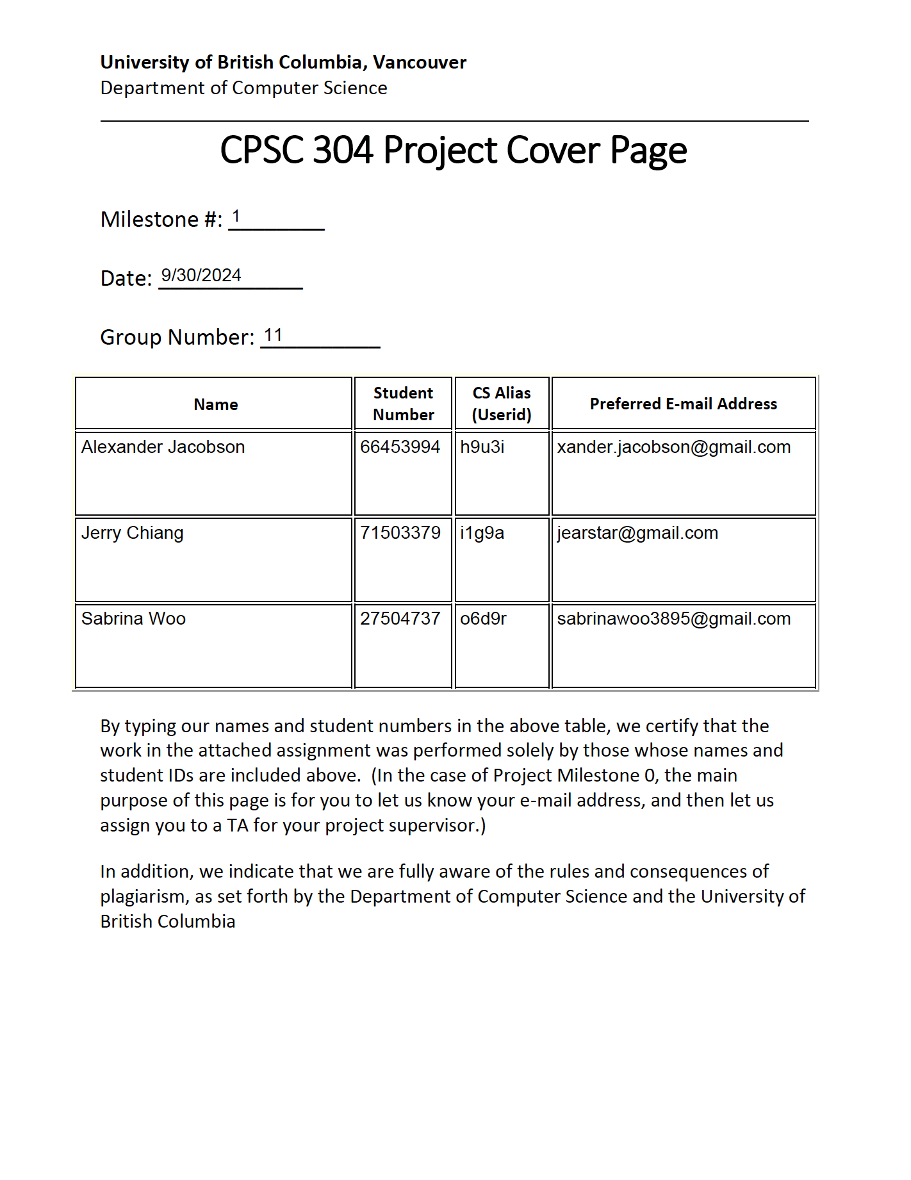

Our group plans to design an application which we have nicknamed “Foodie”, whose domain is food service & management. Foodie will essentially be a more specialized version of Tripadvisor or Yelp, specifically designed for reviewing restaurants and cafes in detail (we will more generally refer to these as “food locations”). As is, most review platforms do not tell users much about food locations; all users get is an overall rating. In order to get an idea of which dishes are the best, or how busy the restaurant typically is, a user would typically have no choice but to comb through many individual reviews.

Foodie intends to alleviate this issue. To create an account, all a user will need is a password and associated email. After dining at a food location, a user can log in and create a new review; as part of this, they would provide an overall rating (from 1 to 5 stars) of the food location, as well as the ratings, prices, and comments of the specific dishes they ordered. If a dish is not already in the system, the user can add it by additionally listing its name, genre, and any dietary restrictions that are incompatible with it. This review also includes the wait times the user experienced, alongside with the time and day of the week they dined, as well as any comments on the service and amenities. A user can also include captioned photos they took of their dishes or of the food location.

If a user has no interest in leaving a review and simply wishes to find a place to eat, they can search and filter through a list of nearby food locations, in which only the essential information for each food location is shown (e.g. name, distance, top 3 rated photos, and overall rating). Within the page for a food location, the user can view the prices and ratings of each dish, as well as a summary of what other users have said about them. If the user wishes, they can view the full list of reviews that have been contributed. They can leave likes on useful reviews, or comments if they have any residual questions. All photos provided alongside a review are placed into the food location’s photo gallery and can be liked too (it is worth noting that liking a user’s photo does not leave a like on their associated review, and vice versa). Naturally, different users have different tastes for food, making some reviewers seem more credible than others. Thus, a user can view someone’s profile through their review and see what they’ve said about other food locations.

All user, review, dish, and food location data will be stored in a mySQL relational database. The only thing that will not be included in the database are the distances to each food location, as these will be calculated dynamically. When searching for nearby food locations, the user will enter their address, and the food locations with the nearest coordinates will be returned. We will use React.js to create our frontend, Express.js for our backend, and Github for version control.

